**ESE 224 Project Report**

Patrick Chen

Bassel El Amine

Ammad Mehdi

**Description**

In this project we needed to implement the Hangman game using C++. The way the game works is, we are asked to guess a letter of a word and hopefully get it correct. If the letter is a part of the word and it is correct, then the letter said is added to uncover the missing word. If the letter is not a part of the word, then it is not correct and a body part shall be added to the “hangman”. The body parts are the head, torso, left arm, right arm, left leg, and right leg. If all of these body parts are added back to the “hangman” then the player loses. If the player reveals the word before all body parts are added, they win!

**Operation**

When the program is running, the console shown in Figure 1 below pops up, and asks the user to enter a number (1, 2 , or 3) to either start a new game, sign in as a user, or sign in as an admin, or to simply enter the character ‘q’ to quit the console. If we choose to enter ‘1’, then the program executes what it intended to execute for the first part of the project, that is, it starts a new game of Hangman. For this second part of the project, the options to enter ‘2’ and ‘3’ were added to the console, where the user (regular user or admin) is then asked, as shown in Figure 8 below, to choose between the characters ‘1’ to ‘5’ to enter to either 1. Play a game, 2. Check history, 3. Check ranking, 4. Become a premium member, or to 5. Clear history. If the user were to choose ‘4’, then they would have the option to choose between becoming a first level or a second level premium user. Moreover, all user information is now stored in a file UserAccountHistory.txt and is updated automatically after the input of a new user in the console. Only the premium user is allowed to clear their history and check the rank. The program will check whether the user is a primum user. For the administrator, it can 1. Sort the list alphabetically, 2. Add a word to the list, or 3. Delete a word from the list.

In out project, we add the extra features that user can choose between first level primum user and secondary level premium user. For the first level primum user, it will have the benefits, every time it plays a game, the word he guesses displayed to him directly. For the secondary level primum user, it has extra three chances to guess the word. In the “UserAccountHistory.txt”, if a user is first level primum user, the file displays “1” under the “Primum” column, it displays “2” under the “Primum” column, if a user is secondary level primum user. If user is not a primum user, it displays “false”.

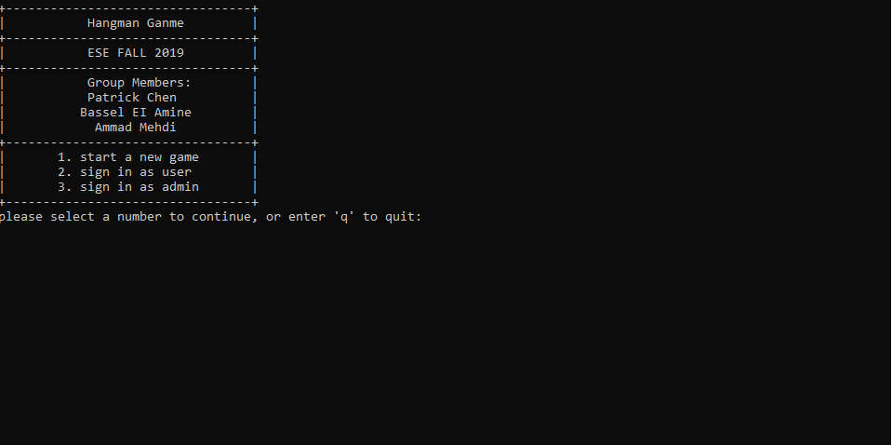

**Figure 1:** Main Menu.

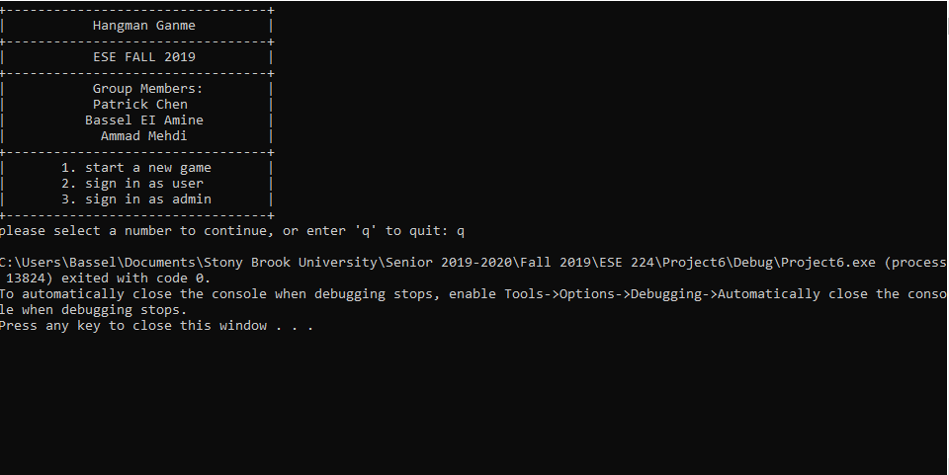

**Figure 2:** ‘q’ is pressed.

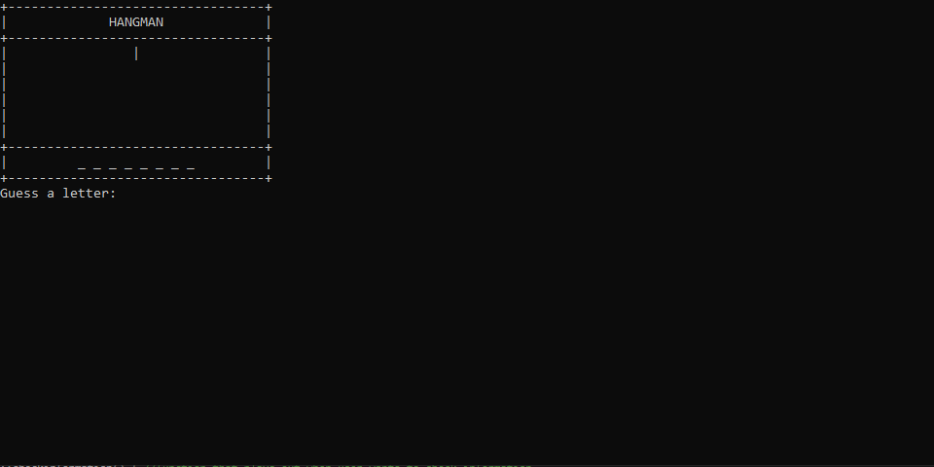

**Figure 3:** Character ‘1’ is pressed, playing game.

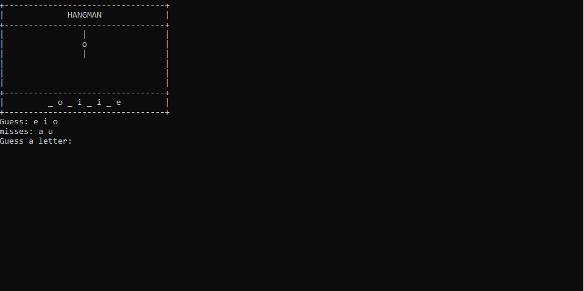

**Figure 4:** Playing game.

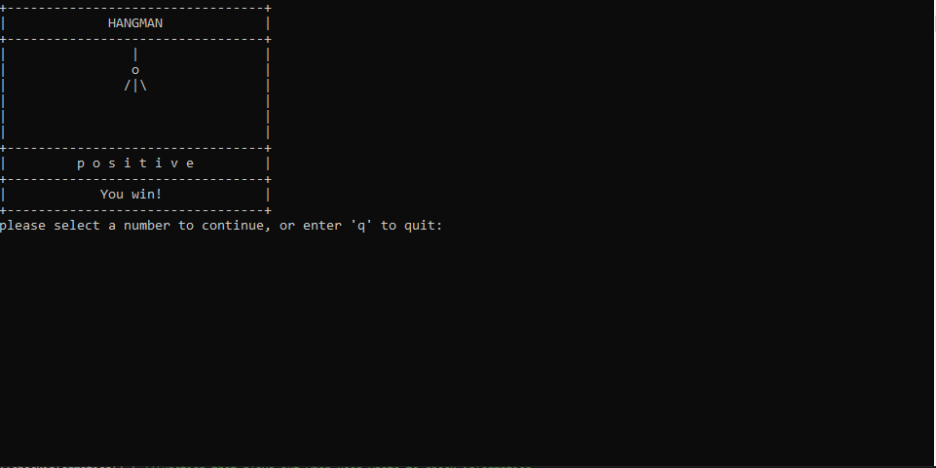

**Figure 5:** Game won!

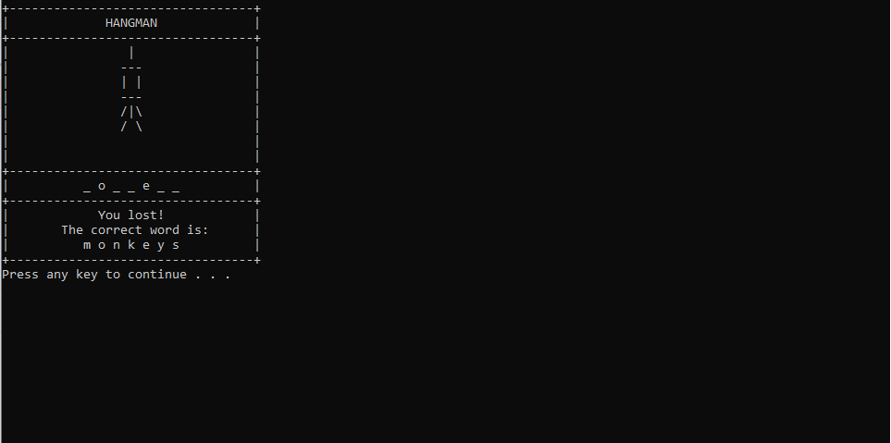

**Figure 6:** Game lost!

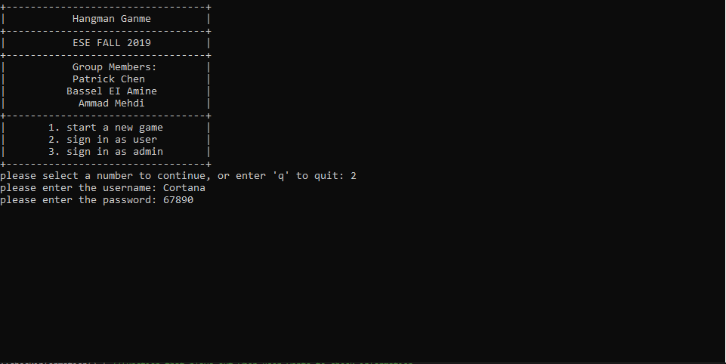

**Figure 7:** Character ‘2’ is pressed in main menu, entering user credentials.

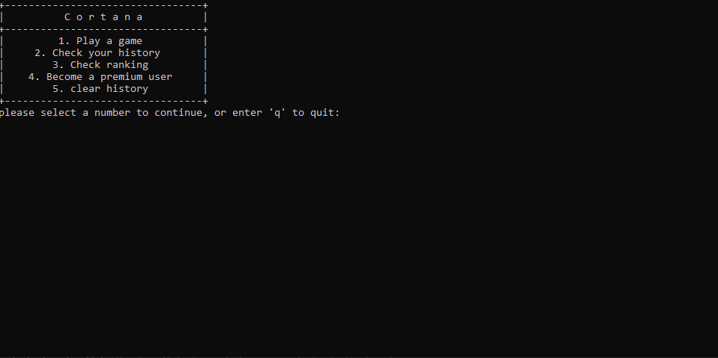

**Figure 8:** Options layed out after signing in as user.

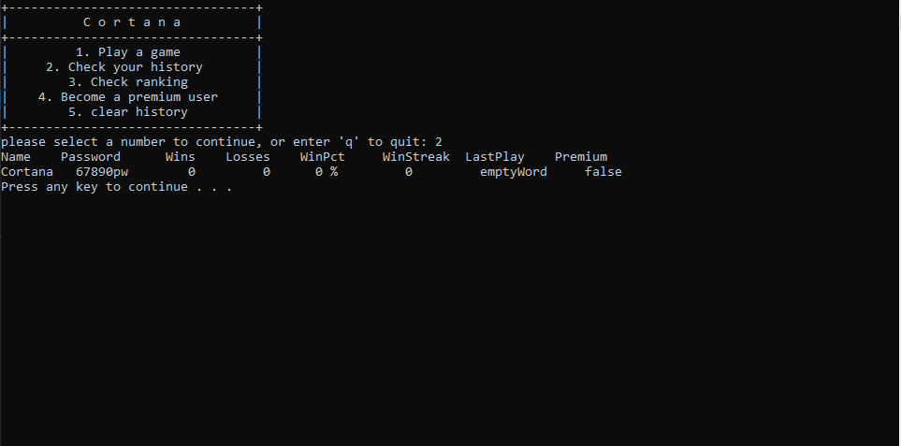

**Figure 9:** Checking user history by entering character ‘2’ in user window.

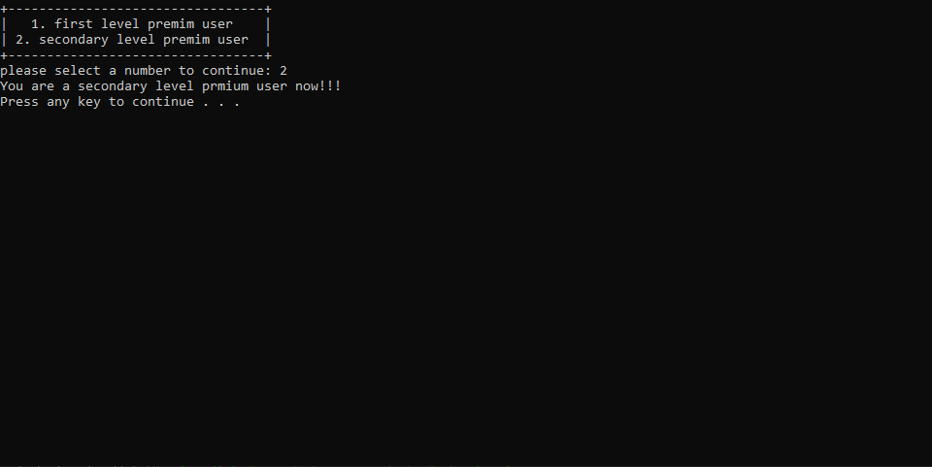

**Figure 10:** Becoming premium member, after entering ‘4’ in user window.

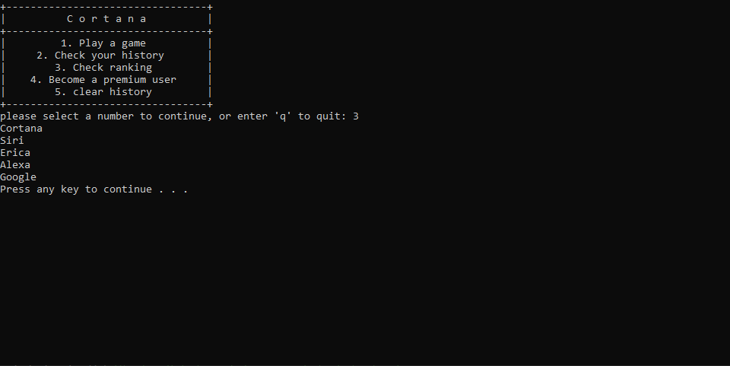

**Figure 11:** Checking users ranking after entering ‘3’ in user window.

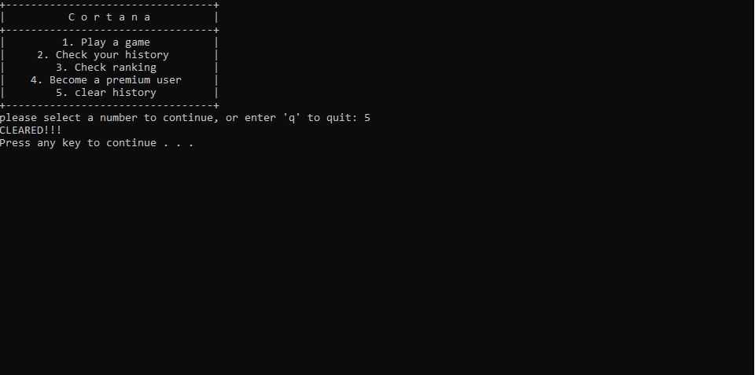

**Figure 12:** User history cleared after entering character ‘5’ into user window.